1. What does the getElementbyId ( ) method do?

**Returns the element that has the id of the given argument in the parameters**

1. What does the innerHTML element do?

**Allows you to change the content of the given element.**

1. What does the document object do?

**It is a built-in object that comes with several properties and methods like the ones from questions 1 and 2 from the DOM.**

1. Review the code on page 230. How would I alter the code.js file to get the code8 element and add the word “rise” to it and return it in an alert window?

**Var access = document.getElementbyId(“code8”);**

**Var code = access.innerHTML;**

**Code = code + “ rise”;**

**Alert(code);**

1. Review the code on page 236, draw a DOM and insert it here.

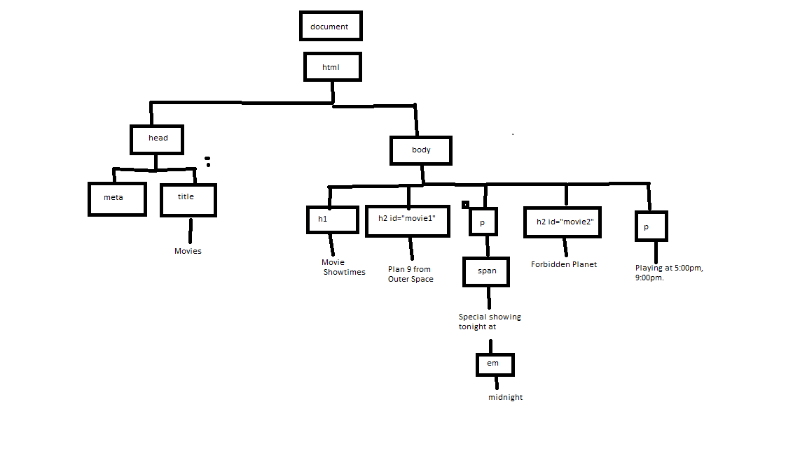

1. For the code on page 236, how would I alter the code to make sure that the movie2 element displays the text color in red for this line: “Playing at 5:00 pm, 9:00 pm”?

**Include class = “redtext” in h1.**

**Must also include a <style> with a var named redtext given the color red.**

1. Describe how an event handler works in the browser.

**When an event occurs, it should call a given function of the object in response back.**

1. How does the getAttribute method work? Show me an example of it in a line of code in JavaScript.

**It returns the attribute of the given name. ____.getAttribute(“alt”);**

1. How does the setAttribute method work?  Show me an example of it in a line of code in JavaScript.

**It finds the name of the attribute you want to change in the first argument and changes it to what you want in the second argument.**

**Planet.setAttribute(“class”, “redtext”);**

1. What is the DOM?

**Direct Object Model. It is a way HTML and Javascript interact and how a document is accessed and manipulated.**